Purchase Order Commitments/Uncommitments

Purchase Orders
All purchase orders write GL cost documents and GL cost transactions.
Whether or not a PO updates the COMMITTED balance is determined by the COMMITTED balance name Commit To GL value at the time the PO is created. The Commit To GL value is stored on the PO header.
PO tax lines (document line between 9000 and 9499) and freight lines (document line between 9500 and ???) never update the COMMITTED balance.
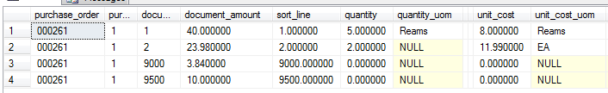
PO Receivers
When a PO is received, Empower writes
purchase_order_applications
purchase_order_application_items
with a document type of PORCVU.
The purchase_order_application_items
- Reference back to the purchase_order, purchase_order_release, and purchase_order_document_line
- Don’t have a unit_cost column
- Have an applied quantity which is populated with the received quantity
- If the PO updated the COMMITTED balance
  - Have an uncommitted quantity which is populated with the received quantity
  - Have a document amount that is calculated using the unit_cost from the PO item times the uncommitted_quantity
  - Have the same posting_accounts as the PO item
Sample PORCVU purchase_order_application_items.
Because purchase_order application_items. document_amount is zero for a PO that didn’t commit to GL, the corresponding gl_cost_transactions document_amount is also zero in that case.
AP Invoices against a PO that was received
When a received PO is invoiced, Empower writes
purchase_order_applications
purchase_order_application_items
with a document type of APINVU.
The purchase_order_application_items
- Reference back to the purchase_order, purchase_order_release, and purchase_order_document_line
- Don’t have a unit_cost column
- Have an applied quantity of 0
- Have an uncommitted quantity of 0
- Have a document amount of 0 (because they don’t uncommit)
- Have an applied amount equal to the ap_document_item amount
- Have a posting account of the commitment clearing posting account for the ledger
- Write $0 gl_cost_transactions
Sample APINVU purchase_order_application_items.
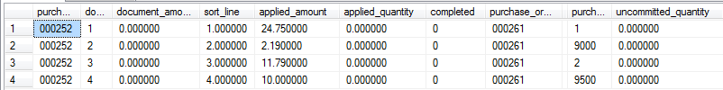
When a received PO is invoiced, Empower also writes
po_receiver_application_items
linking the AP source document to the PO receiver document.

PO Year End
PO Year End writes
purchase_order_year_ends
purchase_order_year_end_items
with a document type of POYE.
Sample purchase_order_year_end_items.
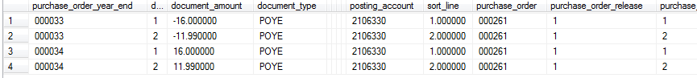
In the above example,
000033 is uncommitting the remaining balance in 2016
000034 is committing the remaining balance in 2017
PO Year End sets the Current Fiscal Year on the PO to the year that holds committed balance.
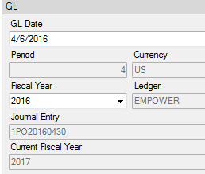
No purchase order application rows are written by PO Year End.
No PO receiver application item rows are written by PO Year End.

Changes to POs that have gone through PO Year End
When a change is made to a PO that has gone through PO Year End, Empower
- Updates the PO’s gl_cost_transactions in the fiscal year of the PO
- Creates additional PO year end documents to make a corresponding change to all PO year ends.
For example, if the amount on PO line 1 is decreased by $8, then
- The PO item commitment was taken down by $8
- The previous PO year end uncommitment of $16 in 2016 should have been an uncommitment of only $8 so Empower creates an $8 adjustment.
- The previous PO year end commitment of $16 in 2017 should have been commitment of $8 so Empower creates a -$8 adjustment.
I believe Empower does something similar if a document applied to a PO that has gone through PO year end is changed.

